Secure IIoT-Based SCADA Motor Temperature Monitoring and Alert System

1. Introduction
Industrial Internet of Things (IIoT) plays a crucial role in modern industries by enabling real-time monitoring and automation. This project demonstrates a simulated SCADA-based motor monitoring system using Modbus protocol, where temperature is continuously observed and alerts are generated when unsafe conditions occur.

2. Objective
The main objectives of this project are:
- To monitor motor temperature using Modbus protocol
- To visualize real-time data using Node-RED dashboard
- To generate email alerts when temperature exceeds 70°C
- To implement cybersecurity concepts in IIoT systems

3. Tools and Technologies Used
- Node-RED
- Modbus TCP Server (Python)
- SCADA Demo Machine Interface
- Gmail SMTP (Email Alert)
- Kali Linux

4. System Architecture
SCADA Motor → Modbus Server → Node-RED → Dashboard + Alert System → Email Notification

5. Methodology

Step 1: Modbus Server Simulation
A Python-based Modbus TCP server was used to simulate motor temperature values ranging from 20°C to 70°C.

Step 2: Data Acquisition
Node-RED reads temperature values from the Modbus server using Modbus Read node.

Step 3: Data Processing
The received data is converted into numerical format using a function node.

Step 4: Condition Monitoring
A threshold condition is applied:
- If temperature ≥ 70°C → trigger alert through email

Step 5: Alert System
An email is sent automatically using SMTP when the threshold is crossed.

Step 6: Dashboard Visualization
Temperature values are displayed in real-time using a gauge in Node-RED dashboard.

6. Node-RED Flow Explanation
The flow consists of the following components:
- Modbus Read Node → Reads temperature
- Function Node → Converts data format
- Switch/Logic Node → Checks condition (≥70°C)
- Email Node → Sends alert
- Dashboard Gauge → Displays temperature

7. Screenshots

Screenshot 1: SCADA Motor Interface

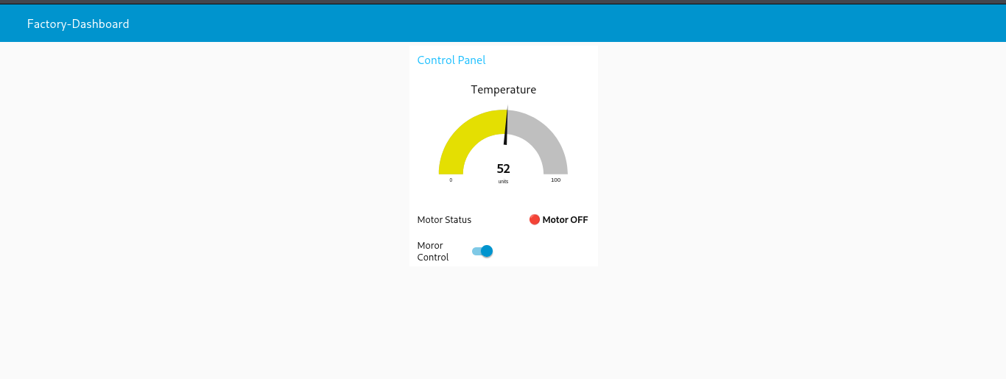

Screenshot 2: Node-RED Flow

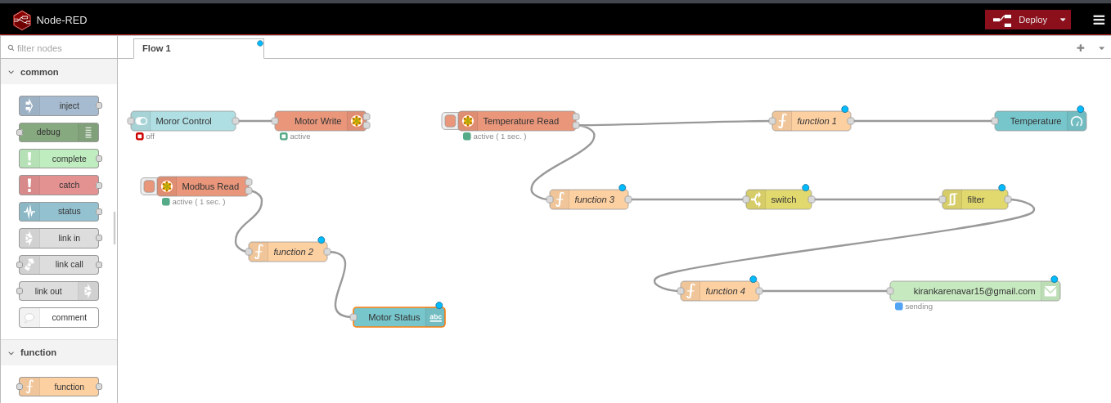

Screenshot 3: Email Alert Received
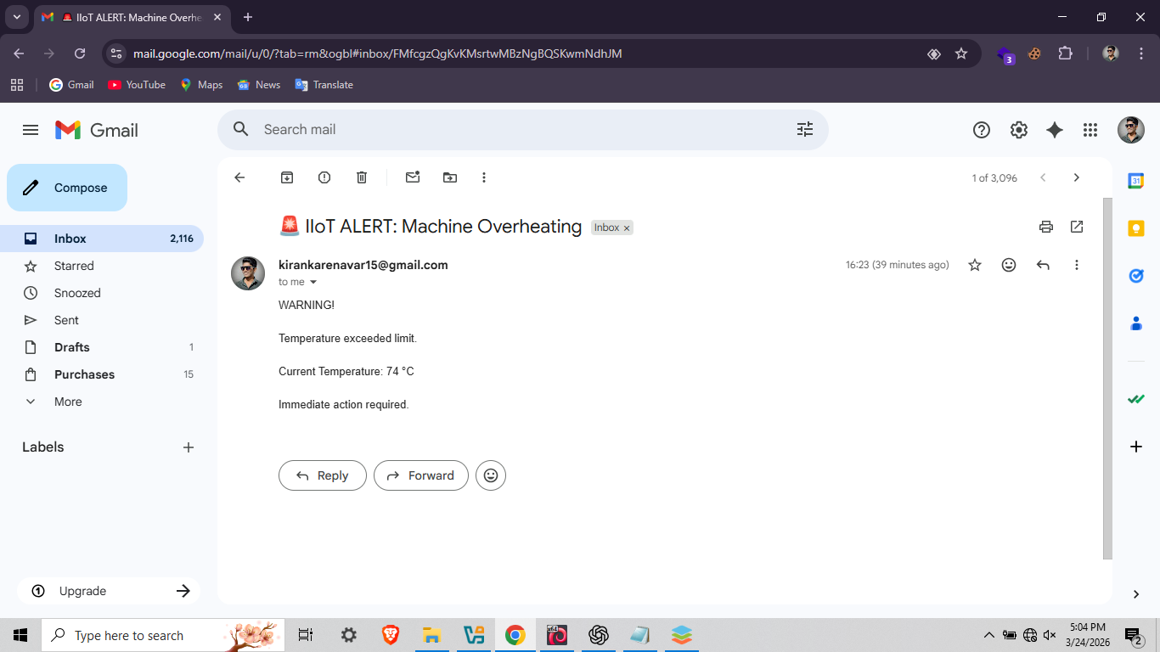
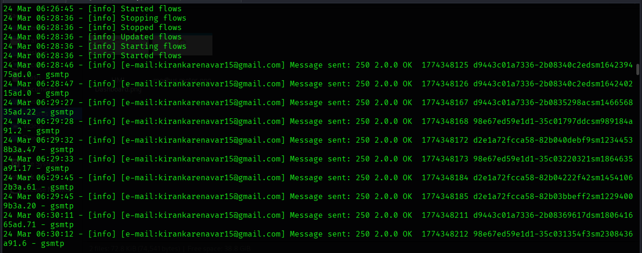

Screenshot 4: Dashboard Temperature Gauge



Screenshot 5: Modbus Server Running
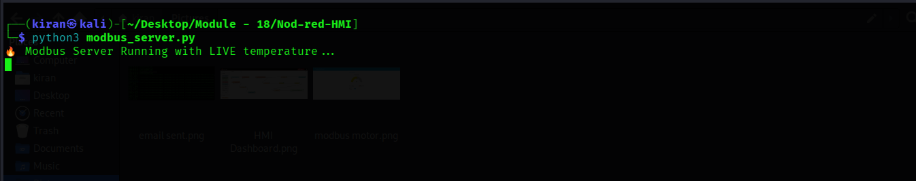

8. Alert Logic Implementation
To avoid repeated alerts, a state-based logic was implemented. The system sends an email only when the temperature crosses 70°C from a lower value, preventing multiple alerts.

9. Cybersecurity Implementation
The following security measures were considered:
- Secure email authentication using App Password
- Controlled access to Node-RED
- Monitoring abnormal conditions (temperature threshold)
- Prevention of alert flooding

10. Results
- Real-time monitoring of motor temperature achieved
- Alert successfully triggered when temperature ≥ 70°C
- Dashboard visualization working correctly
- No repeated alerts due to smart logic implementation

11. Advantages
- Real-time monitoring
- Automated alert system
- Easy to implement
- Scalable for industrial use

12. Limitations
- Simulation-based system (no real hardware)
- Dependent on network connectivity
- Basic security implementation

13. Future Scope
- Integration with real sensors (ESP8266/ESP32)
- SMS/Telegram alerts
- AI-based predictive maintenance
- Cloud integration (AWS/Azure IoT)

14. Conclusion
This project successfully demonstrates a secure IIoT-based monitoring system for a SCADA motor. The system efficiently detects high temperature conditions and generates alerts, ensuring safety and reliability in industrial environments.

